Instruction
for the use of Salary Project module in
Raiffeisen Business Online System



Raiffeisen Business Online Support Service  (Monday – Friday 8:00-22:00,  Saturday - Sunday 8:00-20:00)  clientbank.support@raiffeisen.ua |  | For calls from abroad |  | Currency Transactions Support Service  (Monday – Friday  9:00-18:00)
0 800 505 770  0 800 400 470  + 38 (044) 495 41 40  (in Kyiv and from abroad) |  | +38 (044) 230 99 98  (according to the tariffs of the operator)  raif@phone.aval.ua  (free Skype calls) |  | 0 800 400 425  0 800 500 025  +38 (044) 299 10 99  (in Kyiv and from abroad)
Ukraine, Kyiv, 01011, 4a Generala Almazova Str., https://raiffeisen.ua/

1. Salary Project (including employee share schemes and other joint projects)
2. Contracts
2.1. Viewing the list of the contracts.
2.1. Viewing the contract details page
3. Employee dictionary
3.1. Viewing the employee list
3.2. Viewing the detailed information on an employee
3.3. Exporting the employee list
3.4. Importing employees holding accounts at other banks.
3.5. Creating employees holding accounts at other banks.
4. Salary payrolls.
4.1. Viewing the list of the payrolls
4.2. Viewing the detailed information on a payroll
4.3. Searching recipients in the payroll review mode.
4.4. Creating a new payroll
4.5. Importing employees into a payroll in dbf, xlsx, iBank2(txt) formats.
4.6. Importing a payroll in the text format.
4.7. Signing a payroll.
4.8. Editing a payroll
4.9. Searching recipients on the payroll details page.
4.10. Rejecting a payroll.
4.11. Deleting a payroll in “Drafts” tag
4.12. Copying a payroll.
4.13. Printing a payroll.
5. Letters sent within the framework of the Salary Project
5.1. Letter as regards rejection of payrolls and other requests for them
5.2. Letter as regards setting/cancellation of the part-time employee status
5.3. Letter as regards dismissal of an employee from the Salary Project
5.4. Letter as regards return of funds transferred by mistake
5.5. Letter as regards connecting the employees to the Salary Project
5.6. Letter as regards extension of the salary cards validity term

Salary Project (including employee share schemes and other joint projects)
To work with the Salary Project (employee share schemes or another joint project), go to the Web version of the system in the available functions menu and select Salary (see Fig. 1).
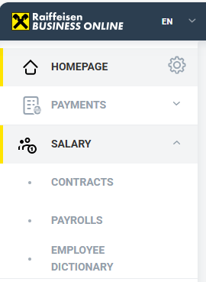
Fig. 1 Main menu

Salary menu consists of the following sections:

- Contracts – viewing the list of the available contracts (a salary project\an employee share scheme\other joint projects), viewing the details of each contract.
- Salary payrolls – viewing\creating\signing\sending to the Bank of salary payrolls.
- Employee dictionary – viewing\creating\editing\deleting employees from the dictionary.

Important!
Before starting to work in “SALARY” section of Raiffeisen Business Online, make sure that the network access to the resource: https://external-api.raiffeisen.ua/ is opened.
The absence of the access can make certain Salary module functions inaccessible.

If the access is opened, the following page will open in the browser:

If the access is closed, you will receive the following message in the browser:

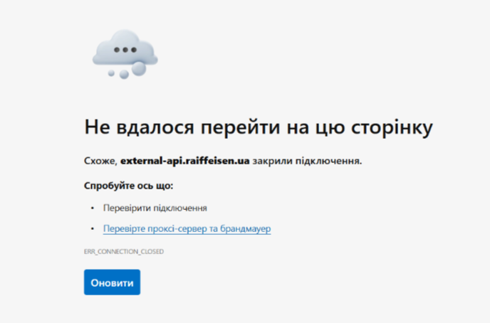
Opening of the network access takes place at the level of IT of the user.

Contracts

Functions available in the section:

- Viewing the list of the contracts
- Viewing the contract details page.

Viewing the list of the contracts.

To view the list of the salary contracts (including employee share schemes and other joint projects), go to “Salary” – “Contracts” section (see. Fig. 2)

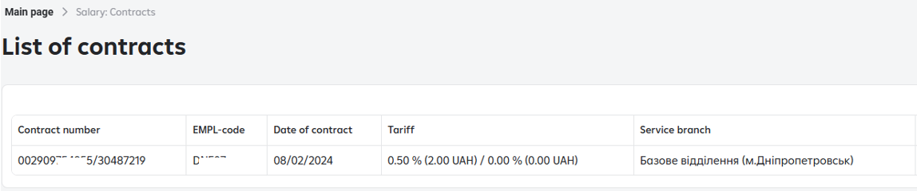
Fig. 2 List of contracts

Viewing the contract details page

To view the detailed information on the contract, in “Salary” – “Contracts” section click on the line in the list with the respective contract (see. Fig. 3).

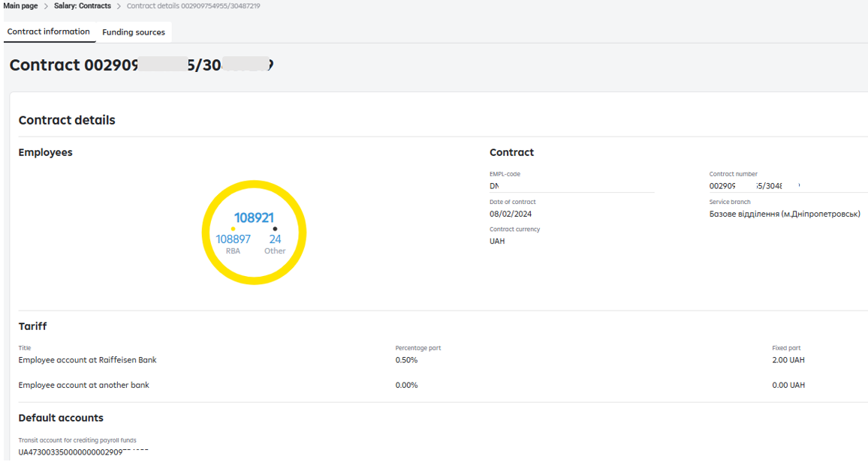
Fig. 3 Contract details.
To view the detailed information on the accounts, from which the payment of the payroll amount is carried out, click on 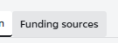 (see Fig. 3).
For your convenience, the possibility to enter the name of the account that will be displayed at the stage of the coverage payment generation while creating a payroll is available in the window.
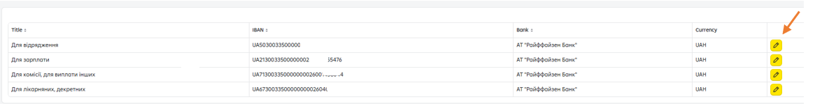
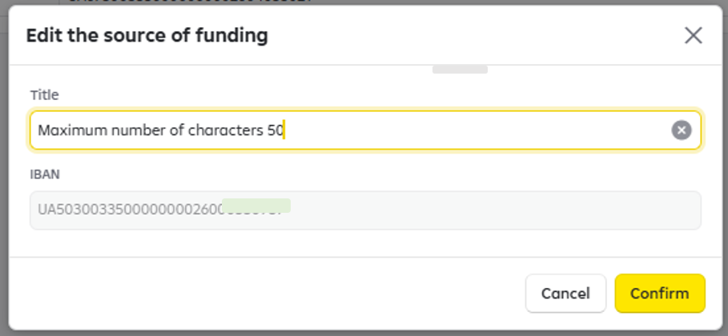
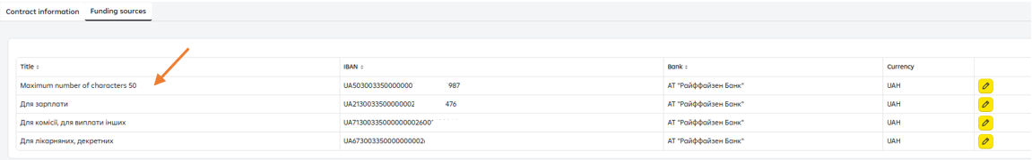

- Employee Dictionary.

Functions available in the section:

- Viewing the employee list.
- Viewing the detailed information on an employee.
- Exporting employees.
- Importing employees holding an account at another bank.
- Creating employees holding an account at another bank.

Viewing the employee list
To view the list of employee dictionaries for all salary contracts, go to “Salary” – “Employee Dictionary” section. (see Fig. 4).

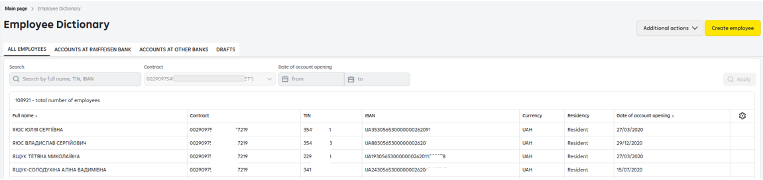

Fig. 4 Employee list

  - Viewing the detailed information on an employee.

To view the detailed information on an employee, click on the line with this employee in the list. As a result, the employee details page will open (see Fig. 5).

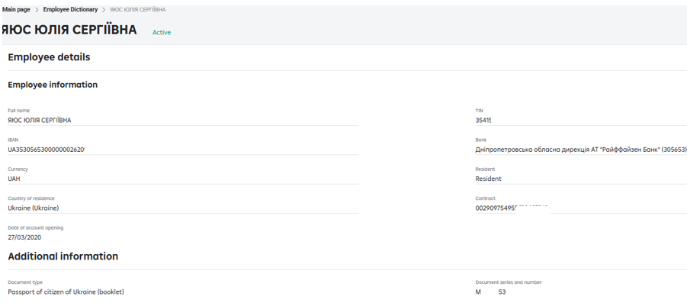
Fig. 5 Employee details

Exporting the employee list

To download the Employee list in хls/dbf format, click on “Additional actions”/”Export” in the Employee Dictionary.

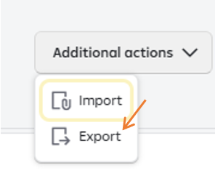

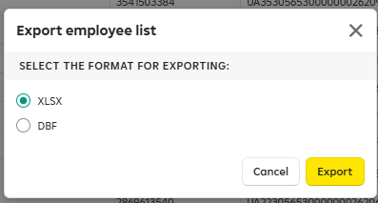

Examples of the export file:

File structure in dbf format:

No. | Field name | Type | Length
1 | ACCT_CARD | Character | 29
2 | FIO | Character | 120
3 | ID_CODE | Сharacter | 10
4 | SUMA | Numeric | The number containing not more than 10 digits in the integral part and 2 digits in the fractional part
5 | OPEN_DANE | Character | 10

  - Importing employees holding accounts at other banks to the Employee Dictionary is possible in .xlsx format.

Click on “Additional actions”/”Import” in the Employee Dictionary on “Accounts in other banks” tab.

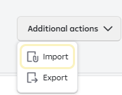
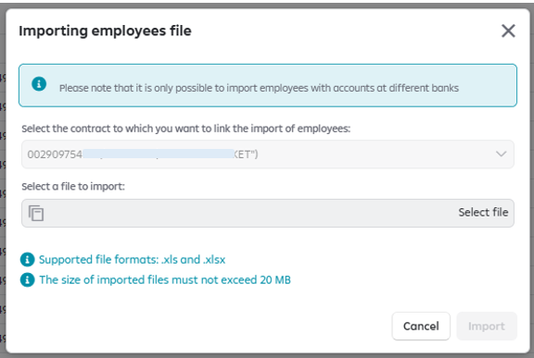

The requirements to the file structure:

IBAN | FULL_NAME | TAX_CODE | DOCUMENT | RESIDENCY
UA123524570000026200511111101 | Ivanenko Oleksandr Oleksandrovych | 1234567891 | МР123456 | 804

  - Creating employees holding accounts at other banks

To create an employee, go to Employee Dictionary/”Accounts at other banks”/”Create an employee” section.

When you click on “Create an employee" button, a window with the list of the mandatory data to be entered will open. If the employee does not have a taxpayer’s identification number (TIN) – the passport data should be mandatorily filled in.

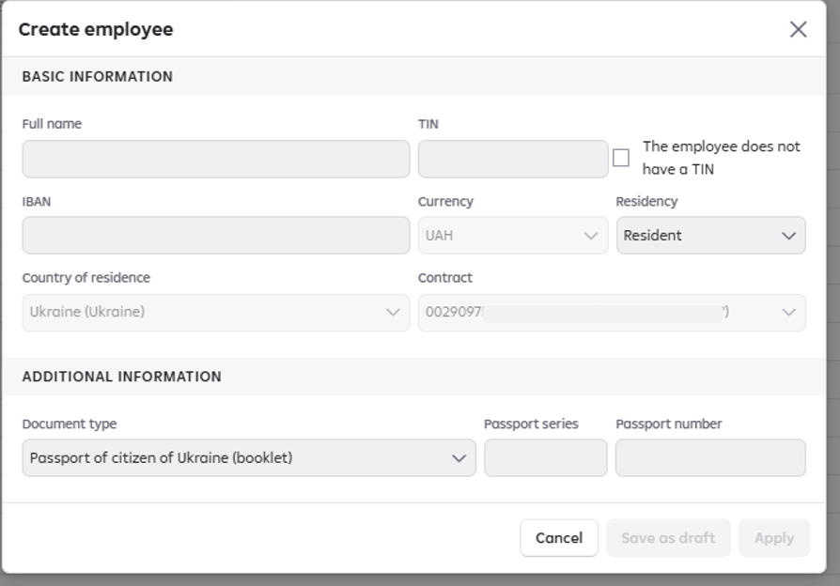

Salary payrolls.

  - Viewing the list of the payrolls

To view the list of the payrolls for all the salary contracts, go to “Salary” – “Salary payrolls” section. A page with the list of payrolls will open (see Fig. 6).
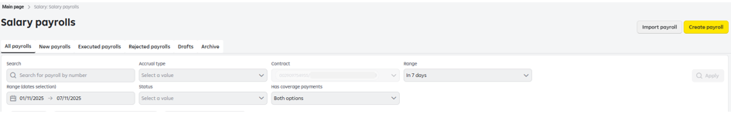

Fig. 6 List of salary payrolls.

- All payrolls – the payrolls in all statuses (7-day period is displayed by default) are displayed here, except for “Draft” and “Archive”.
The possibility of bulk payrolls signing\rejection\printing is available in the section (the action is called out by a click on the check-box to the left when selecting one and more payrolls).

Example:
Selecting one payroll:
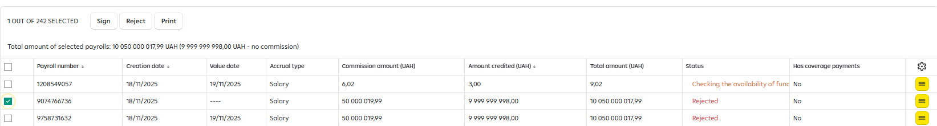

Selecting several payrolls:
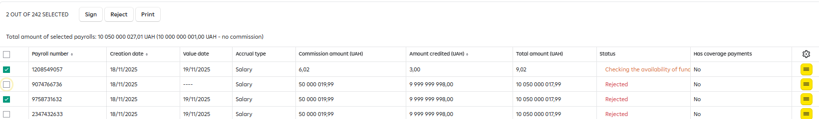

Selecting all the payrolls (is possible by a click on the upper check-box:

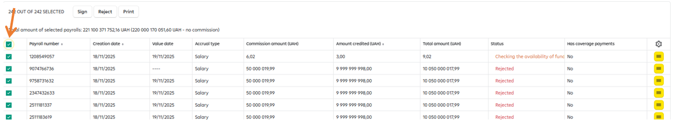

- New – only the payrolls with the status “New” that are automatically selected by the current document date are displayed here.
The possibility of bulk payrolls signing\rejection\printing is available in this section (the action is called out in the same manner, as in the section All payrolls).
- Executed – the payrolls that have the status “Executed” and “Partially executed” are displayed in this section. The possibility of bulk payrolls printing is available in this section (the action is called out in the same manner, as in the section All payrolls).
- Rejected - the payrolls in the status “Rejected” are displayed here. The reason and the initiator of the rejection can be displayed for each payroll in the list. The possibility of bulk payrolls printing is available in this section (the action is called out in the same manner, as in the section All payrolls).
- Drafts – the payrolls in the status “Draft” are displayed here.
The possibility of bulk payrolls deleting is available in this section (the action is called out in the same manner, as in the section All payrolls).
- Archive – the payrolls that were entered into iBank (Bifit) are displayed here.

Attention!
The payrolls in the statuses below are valid for 30 days:
- Signed;
- Awaits the value date;
- Carrying out of the payment is expected;
- Availability of funds check is in progress.
Subject to availability of balance on the account 2909, the Bank proceeds in the automated mode with such payrolls execution within 30 days.
The history of the status change under the payroll, including the payrolls in the status “Partially executed” and “Awaits the value date”, as well as the history of the status change for the payrolls in the final status “Executed”, “Partially executed”, “Rejected” can be displayed.

Examples.
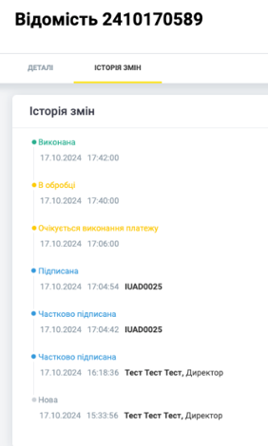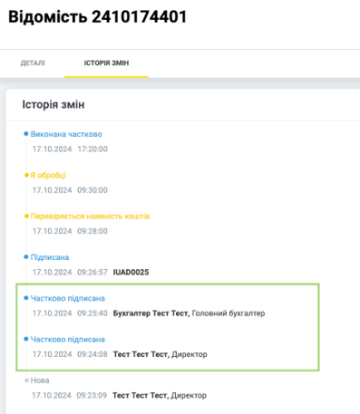

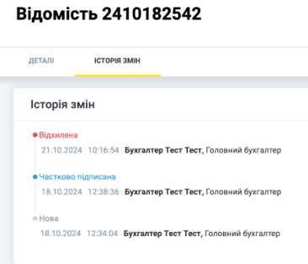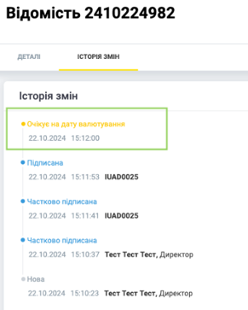

  - Viewing the detailed information on a payroll

To view the detailed information on a payroll, go to “Salary” – “Salary payrolls” section and click on the line with the selected payroll in the list (Fig. 6). As a result, the page with the details will open (see Fig. 7)

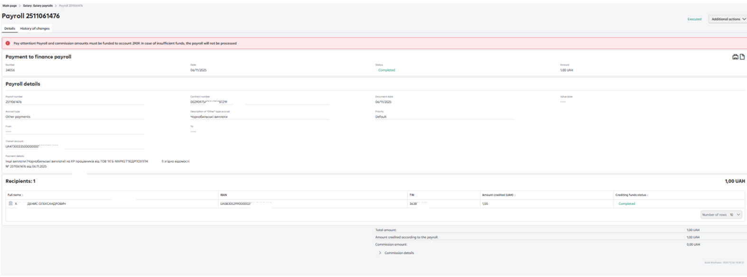
Fig. 7 Payroll details.

Searching recipients in the payroll review mode.

The payroll details review mode (Fig. 7) offers a search field allowing to search the recipient by the full name, IBAN, TIN.

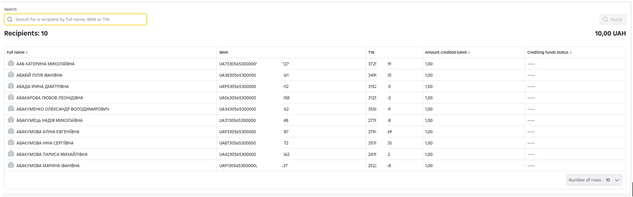
The search field is available, if the number of the recipients is 10 and more (if the number of the recipients is up to 9 inclusive – the specified field is absent) and covers the full list of recipients in the payroll, regardless of the presence or absence of the employee you are searching for on the current list page.
To conduct the search, please, enter the full name\or IBAN\ or TIN of the employee you are searching for in the search field and click on “Apply” button.

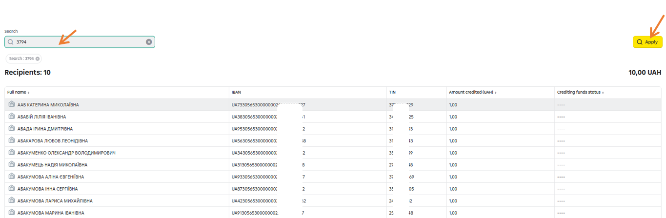

The following search result is received:

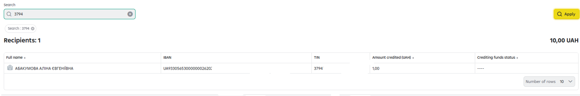

To cancel the search, please, click on the cross on the right side of the field or delete the symbols entered in the field using the keyboard and press “Apply” button.
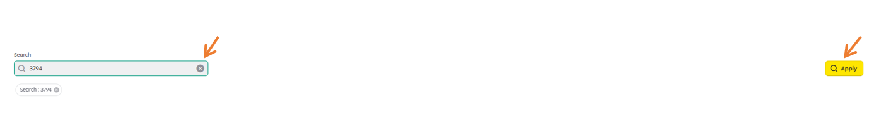
As a result, we return to the first page of the payroll.

Creating a new payroll
To create a payroll, press the button  on the main page of “Salary Payrolls” section (see Fig. 6). If you have several salary contracts available, the contract selection form will open (see Fig. 8).

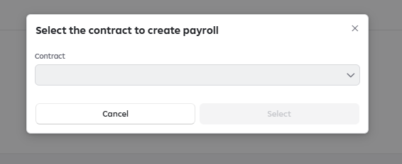
Fig. 8 Selection of the contract

In the form, select the contract, to which you want to create a payroll and click on “Next” button. As a result, a draft payroll will be created and the payroll creation form will open (see Fig. 9).

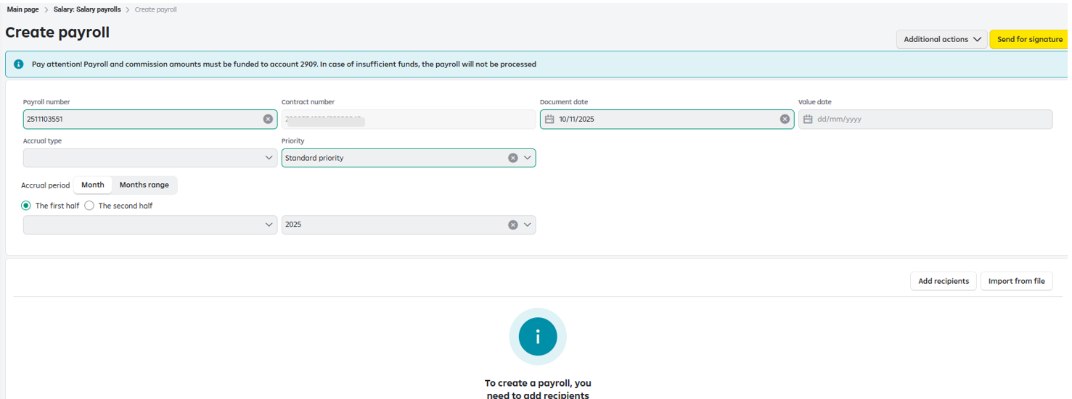

Fig. 9 Creation of a payroll

The following fields must be filled in in the form:

- Number – by default, the number will be generated automatically, but it can be edited:

Parameters:
- Maximum number of symbols – 10
- Allowed symbols: digits and Cyrillic/Latin upper case/lower case letters.
- Allowed special symbols: "+" "-" "_" "/" "№" "#" "$"
- Document date – the current date is displayed in the calendar by default.
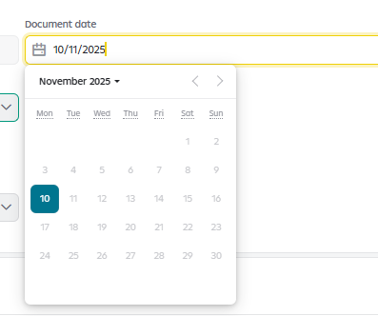

- Value date – is used, if the payment under the payroll needs to be postponed and executed on the specified value date, but not more than by 30 days. The value date cannot coincide with the current date.
- Accrual type – select from the list the payroll accrual type;
For the accrual type “Other payments”, an dditional test field “Description of “Other” type accrual” is available, where the information that will be reflected in the payment purpose can be specified.

Contract – the field will be filled in with the details of the contract that was selected in the contract selection form (see Fig. 8). If you have one contract, its value will be displayed in the field.
Accrual period – the month and the year should be specified with the following functions available:
- the 1st or the 2nd half of the month;
- time range - 1 month;
- time range - several months.
For example, the required accrual period - the 1st or the 2nd half of the month.
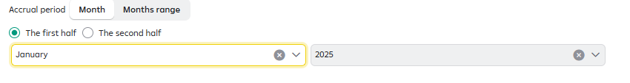
The payroll will be formed with the following payment purpose:
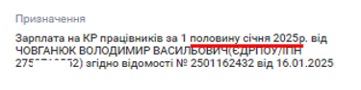
For example, the required accrual period is 1 month.
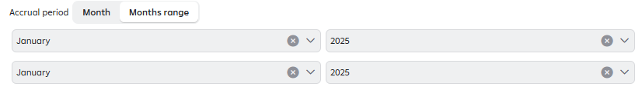
The payroll will be formed with the following payment purpose:



For example, the required accrual period - several months.

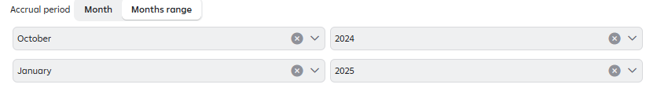

The payroll will be formed with the following payment purpose:
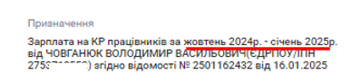

For the accrual types “business trip”, “sick leave allowance”, “maternity leave allowance”, “other payments” – specifying the accrual period is not mandatory (technically it is possible to save\send for signature a payroll, in which the accrual period field is not filled in).
The payroll will be formed with the following payment purpose:
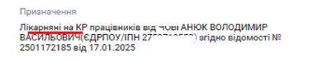

- Payment to finance the payroll amount – the automatically generated payment to finance the payroll amount.
- Payment to finance the commission amount - the automatically generated payment to finance the amount of the commission.
- Priority – the level of priority of the payrolls payment (high/medium/standard). This field should be mandatorily filled in. In case of failure to fill in the specified field – “Standard priority” will be assigned by default.

Carrying out the payment under the payroll with a value date.

This option is used, if the payment under the payroll needs to be postponed and executed on the specified value date, but not later than by 30 days.
The value date in the payroll cannot coincide with the current date, an error notice will be produced by the system during such payroll saving:

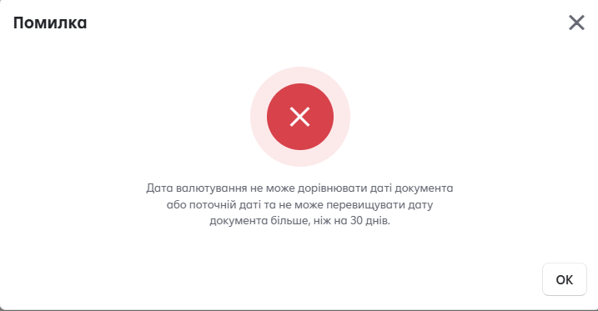

Please, take into account that the payroll has to be signed by the end of the day of the value date. If the payroll is not signed by the value date expiration, it will be automatically rejected. In this case, the payments generated together with such payroll will be rejected as well. If there is a need to reject the payroll before the value date, both the payroll and the payments will be rejected.
The Payment processing will be initiated on the value date. For example, the value date is the 30.04.2024, thus, the funds will be debited from the accounts on the 30.04.2024.

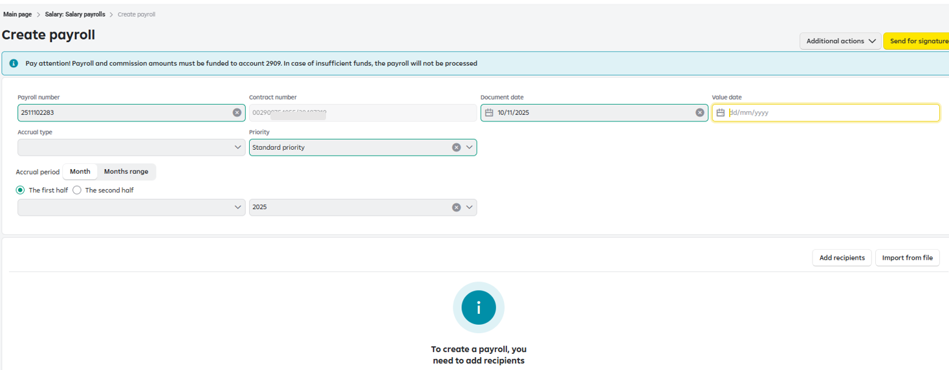

Fig.10. Value date

Setting the payroll payment priority.

This field is mandatory, if the priority level is not selected, “Standard Priority” will be assigned by default

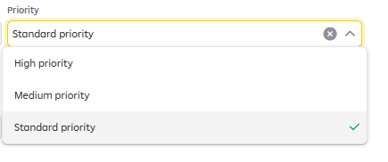

While creating a payroll, you can set the level of priority of the payrolls processing:
- High priority - the payment under the payroll will be carried out in the first place.
Example 1:
You have created two payrolls:
- Payroll No.1 for UAH 400.0 is signed by all the signatories at 10.55 with no priority assigned.
- Payroll No.2 for UAH 600.55 is signed by all the signatories at 10.57 with the High priority assigned.
The amount of UAH 400.00 is available on account 2909. The System will await crediting of funds to the account to carry out the payment under the payroll, to which the High priority is assigned, in other words, the Payroll No.2 will be paid in the first place, when the funds required to finance the Payroll No.2 in the amount of UAH 600.55 is available on account 2909.

Example 2:
- Payroll No.1 for UAH 400.0 is signed by all the signatories at 10.55 with the High priority assigned;
- Payroll No.2 for UAH 600.55 is signed by all the signatories at 10.57 with the High priority assigned;

The amount of UAH 600.55 is available on the account. Thus, the payment under Payroll No.2 will be carried out in the first place, as the amount available on the account 2909 fully corresponds to the amount of the payroll and the same level of priority is assigned to both payrolls.
- Medium priority – the payment under the payroll will be carried out in the second place.
Example:
You have created three payrolls:
- Payroll No.1 for UAH 400.00 is signed by all the signatories at 10.55 with the Medium priority assigned;
- Payroll No.2 for UAH 600.55 is signed by all the signatories at 10.57 with the High priority assigned.
- Payroll No.3 for UAH 100.00 is signed by all the signatories at 10.58 with the Standard priority assigned;
The amount of UAH 400.00 is available on the account 2909. The System will await crediting to the account of the funds required for conducting the payment under the payroll, to which the High priority is assigned, thus, Payroll No.2 will be paid out in the first place, when the amount required to finance the Payroll No.2 for the amount of UAH 600.55 is available on the account 2909, then Payroll No.1, to which the Medium priority is assigned will be paid out and only after that – Payroll No.3, to which the Standard priority is assigned.

- Standard priority - the payrolls will be paid out depending on two criteria: the order of acquiring the status “Awaiting the balance on the account 2909” and the availability of the amount sufficient to finance the payroll amount

Attention! In case of the full matching of the amount available on the account 2909 with the amount of any of the payrolls in the order – the payment under this payroll will be conducted in the first place.
Example 1 :
You have created two payrolls:
- Payroll No.1 for UAH 400.0 is signed by all the signatories at 10.55.
- Payroll No. 2 for UAH 200.55 is signed by all the signatories at 10.57.

The amount of UAH 200.55 is available on the account 2909. Thus, Payroll No.2 will be paid out in the first place, as the balance amount of the account fully corresponds to the amount required to finance the Payroll No.2.

Example 2 :
You have created two payrolls:
- Payroll No.1 for UAH 400.00 is signed by all the signatories at 10.55.
- Payroll No. 2 for UAH 200.55 is signed by all the signatories at 10.57.
The amount of UAH 500.00 is available on the account 2909. Thus, Payroll No.1 will be paid out in the first place, as the amount required to finance it is available on the account and it is signed earlier than Payroll No.2.

You can add recipients in two ways:

  - Add manually by selecting from the dictionary
  - Import the recipients to the payroll (clause 4.5.).

Having filled in all the data, click on the “Send for signature” button at the top of the page. The payroll will be checked and saved in the system in the “New” status.
If you do not fill in the payroll completely, you can use the “Save as a Draft” option to continue filling it in later.

Adding the recipients to the payroll
To add recipients to the payroll, on the payroll creation/editing page in the block containing the information on the recipients, press the button . A form with the employee list will open (see Fig. 11)

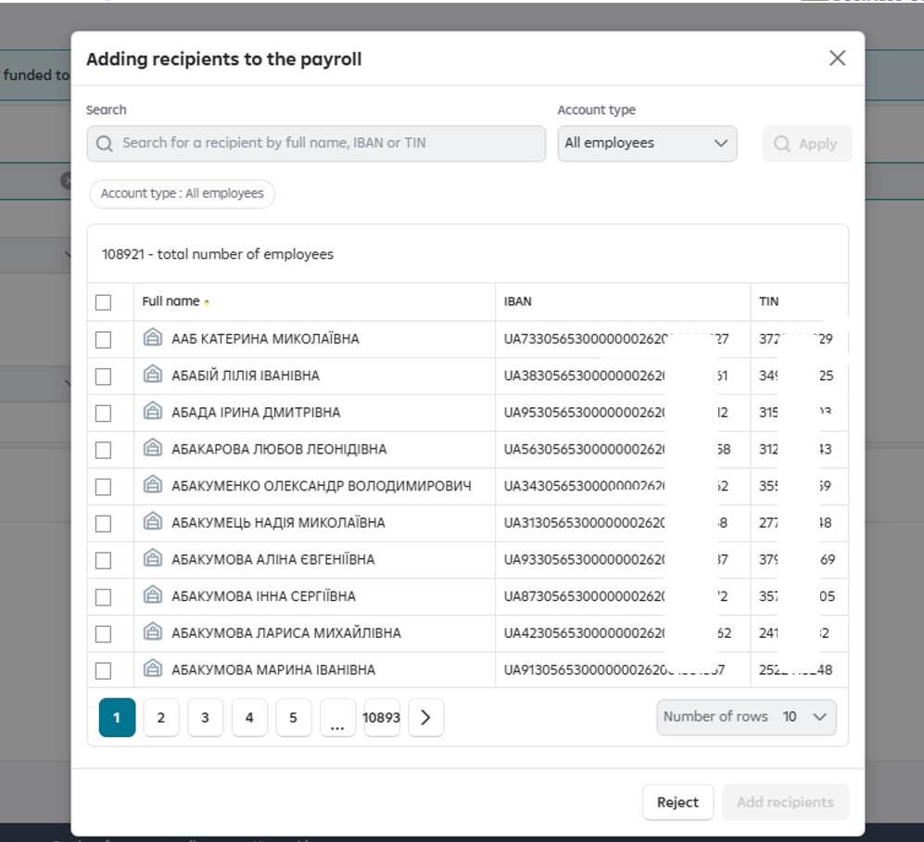
Fig. 11 Selecting the recipients.

For your convenience, in the drop-down menu , the Account type is accessible for selection:

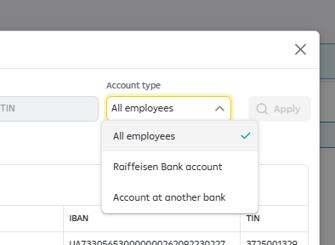

To apply filtering, having made the selection, press “Apply” button in the drop-down menu.

Check the checkboxes next to the required recipients and press the “Add recipients” button.

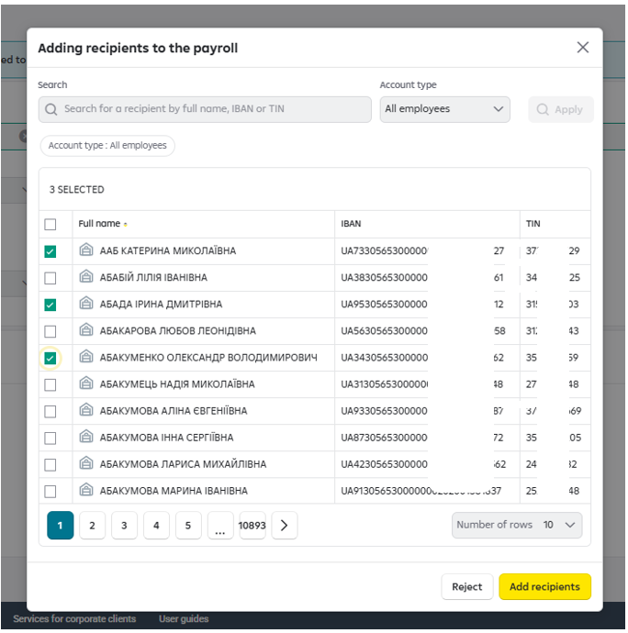

As a result, the payroll creation page with the list of the added recipients will open, in which you can enter the amount to be paid to each recipient (see Fig.12)

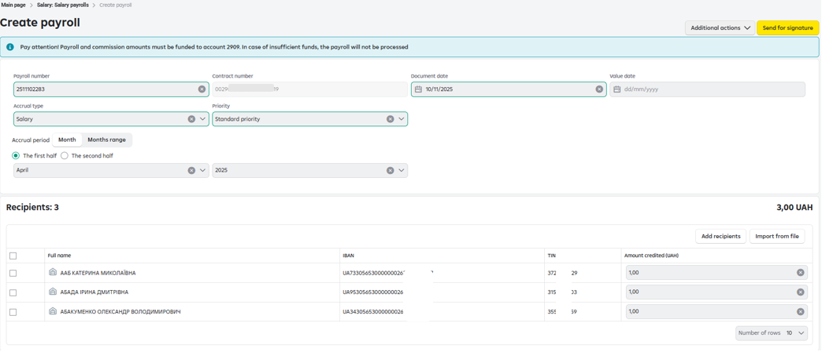
Fig. 12 Payroll with the recipients added

Function of the automated generation of payments under the payroll.

Attention!
This function provides the possibility to:

- EITHER generate automatically the payments to finance the payroll amount (you DO NOT NEED to fill in separately the payments to finance the statements in “Payments” section of RBO);
- EITHER NOT TO generate automatically the payments to finance the payroll amount (you need to fill in separately the payments to finance the statements in “Payments” section of RBO).
After you click on “Send for signature” button  , you will have the possibility to generate automatically the payments to the payroll by clicking on “Generate payments” button or just to create a payroll WITHOUT THE PAYMENT TO FINANCE THE PAYROLL by pressing “Continue without payments” button.

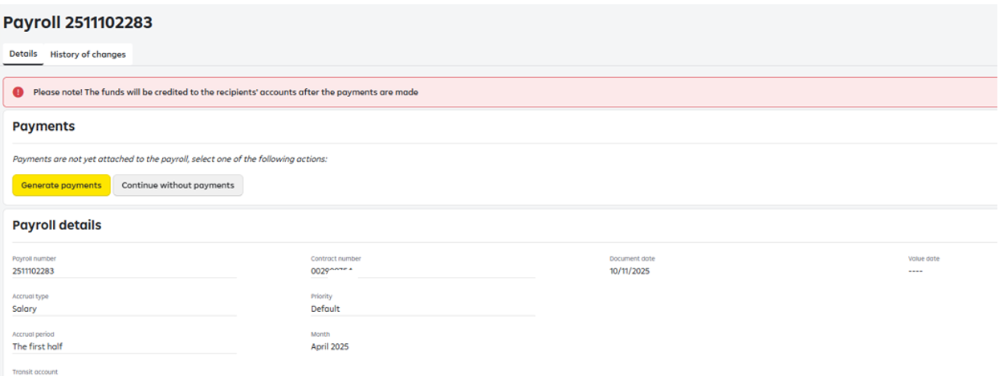

Fig. 13. Automated generation of the payments to the payroll.

Having selected “Generate payments” option, if you have two or more current accounts opened at RB, you need to select the accounts, from which you wish to carry out the payments.

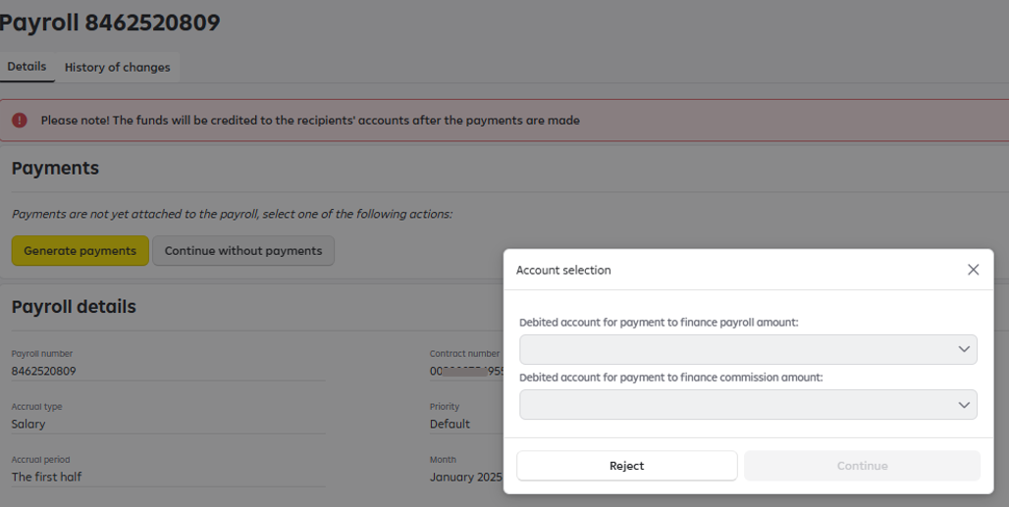
Fig. 14. Selecting the accounts to finance the payroll amount and the commission.

After you have selected the accounts to carry out the payment to finance the payroll amount and the cash and settlement servicing commission (if applicable), an additional notification - reminder will be generated by the system:

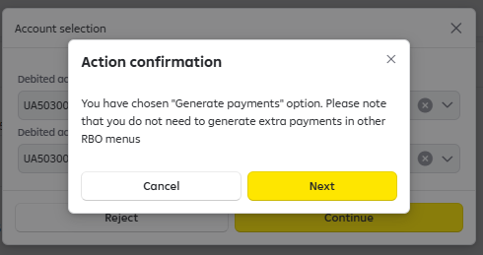

In case of payment of social security allowances (sick leave allowance, maternity leave allowance), account 2604 will become available for selection. At the same time, the payment of the commission while making the payment of social allowances should be made from the accounts of the balance group 2600.

The function of creating payments to finance the payroll amounts from account 2604 for the payrolls with the accrual type “Other payments” is also available, where in the comments field you can specify the nature of another payment made at the expense of the state budget funds (for example, allowance paid to compensate damage to health caused by the Chornobyl Nuclear Power Plant accident etc.).

Example.
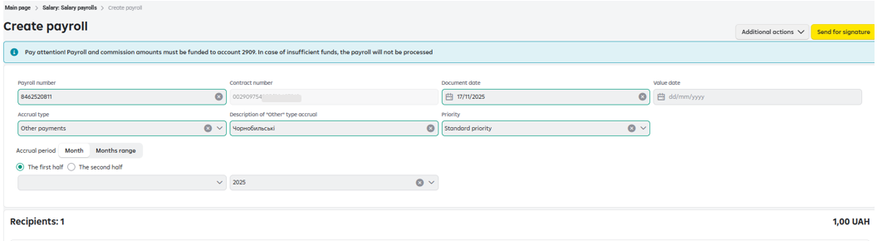
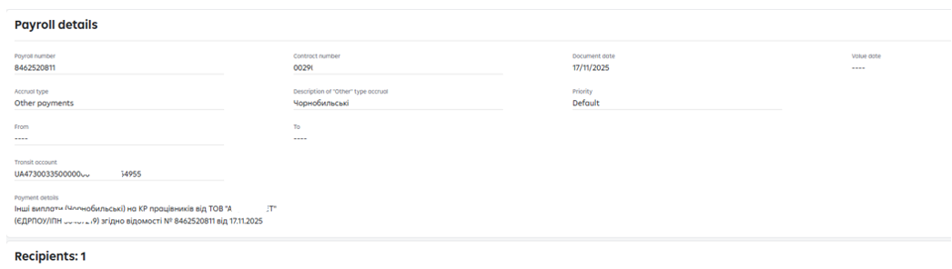

Please, take into account that, while selecting the option “Generate payments”, the payrolls and the formed payments are the only component, in which for a specific payroll, specific payments are created. If you edit the payroll via “Additional actions”/”Edit” option, the specified changes will apply and will be reflected also in the payments conducted to finance the payroll amount and the cash and settlement servicing commission amount.
Having checked the displayed information, press “Sign” button. After the signing, the payroll and the payments will be sent for processing.

Attention!
The details of the automatically created payments to finance the payroll amount and the commission amounts are displayed inside the payroll.

Fig.15. Formed payments to finance the payroll amount and the commission amount.

Clicking on , you can print the payment and clicking on , you can see the detailed information on the payment.

The availability of automatically created payments to finance the payroll amounts are reflected in “Salary payrolls” section with the possibility of search (filtering) by this criterion.
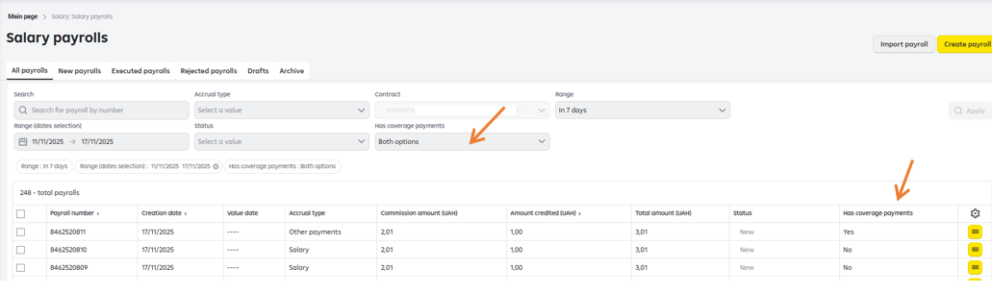

Fig.15

Function: “Continue without payments”

If you select the option “Continue without payments” – the payments to finance the payroll amount and the commission should be formed manually and in such case the payment orders should be created in RBO menu “Payments”.

Example of a payroll creation without an automated generation of the payment to finance the payroll amount:

The 1st Step. Click on “Continue without payments” button.
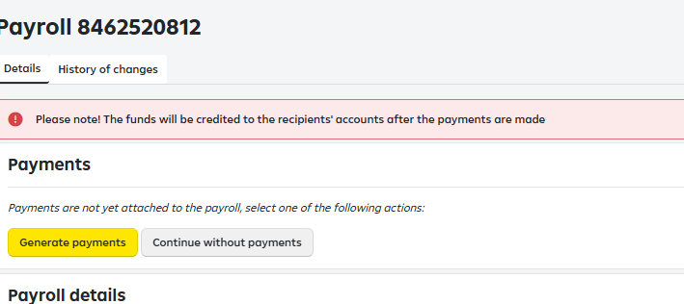

The 2nd Step. Click on “Sign” button.

The option “Generate payments” will be also available at this stage (for your convenience, if you made a mistake in the 1st Step/forgot and need to generate the payments).

DO NOT use this option, if you wish to create a payroll without payments.
Just press “Sign” button.
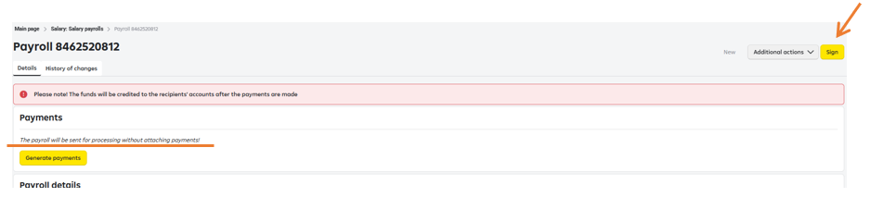

We would also like to draw your attention to the fact that while creating payments in RBO menu “Payments” section on your own, you should use only the account 2909 “Transit account for crediting of salary funds” that is specified in the tab: “Salary”/”Contracts”. This account is opened for servicing the Salary Project in RBO:

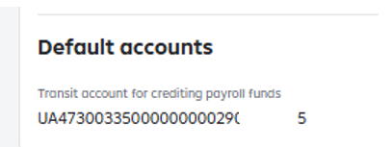

Creating a new payroll with cash and settlement servicing commission.

The process of creation is similar to that described in clause 4.4. At the same time, the Calculation of the cash and settlement servicing commission is reflected after the payroll passes to the status: “New”. To ensure the possibility to make a payment under the Payroll that includes the cash and settlement servicing commission, please, transfer the Amount of crediting under the payroll and the Commission amount to the account 2909 using the menu “Payments”. In case of lack on the account 2909 of the sufficient amount of funds that includes the amount of crediting under the payroll and the amount of the commission, the payment under the payroll will be not carried out.

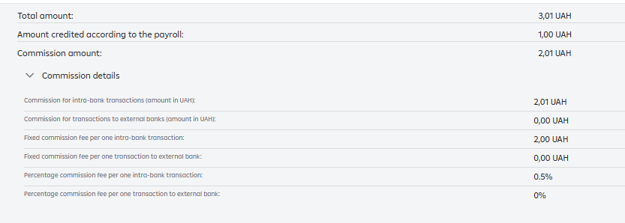

Fig. 16 Cash and settlement servicing commission calculation

Creation of a new payroll in case of financing from another bank.

Creation of a payroll in case of financing from another bank is similar to the process described in clause 4.4. and is carried out with the use of “Proceed without payments” function.
In this case, there is no need to form separately the payment orders for conducting the payments to cover the statement amounts in RBO menu “Payments”. The statement created will be added to the order of the statements to be paid and will await conducting the payment and the payment will be performed upon crediting funds to the account 2909 from another bank.

Importing employees to a payroll in dbf, xlsx, iBank2(txt) formats.

In Raiffeisen Business Online System, the user can add recipients to the payroll by importing a file using the option  on the main page of “Salary payrolls” section (see Fig. 6).

Import process.
To import recipients to the payroll, in the payroll creation/editing form click on the button  (see Fig. 17).

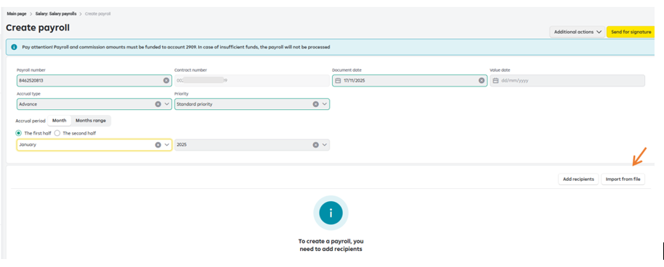
Fig. 17 Importing the recipients to the payroll

In the form (see Fig. 18) press on the button 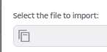 and select the file to be imported.

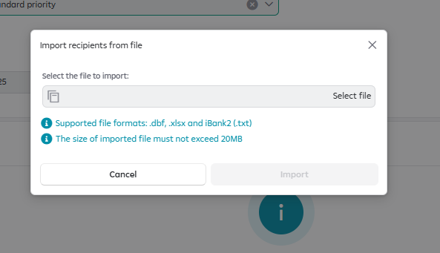
Fig. 18 File selection form

The file will first be checked for viruses, then the data in the uploaded file will be verified. As a result, the verification result will be displayed in the form (see Fig.19)

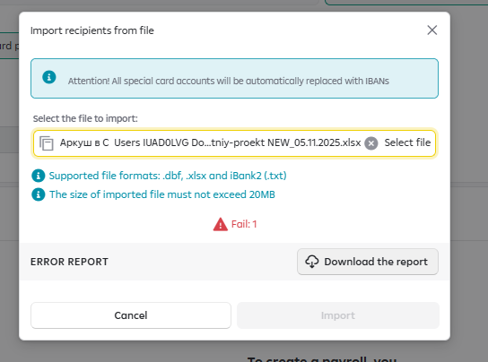
Fig. 19

Note. If the file name contains an apostrophe, the import will not be possible. Make sure the file names does not contain it.
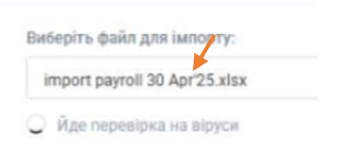

Below the file selection field, you will see the number of records that have successfully passed the verification and the number of records whose verification was unsuccessful that will not be imported into the dictionary.

A detailed import errors report can be downloaded by clicking on the button 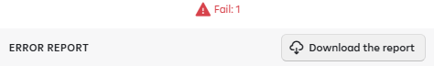

Examples of errors:
Errors for “Account number” field
The account number cannot be blank.
Invalid account number. The account number can consist of either 10 or 29 characters.
This account number is not in the Employee Dictionary. Add the recipient to the Dictionary so that he/she could be added to the payroll.
Errors for “TIN” field
The TIN cannot be blank.
The TIN is invalid. The TIN can consist of up to 10 characters.
This TIN and account number do not match the data in the Employee Dictionary.
This TIN is not in the Employee Dictionary. Add the recipient to the Dictionary so that he/she could be added to the payroll.
This recipient is not in the Dictionary.
Errors for “Amount” field
The amount cannot be blank.
The value must be not less than UAH 0.01
The value must not exceed UAH 9999999999.99
The amount can contain only digits, as well as special symbols such as ".".
The value after the decimal point must contain no more than two digits.
To import recipients to the payroll, click on 
As a result, the recipients who have passed the verification will be added to the payroll and the payroll will be automatically saved as a draft.

Requirements to the file to be imported in DBF format.
Files to be imported in DBF format - spreadsheets in *.dbf format (DBF versions: 3, 4, 5, 7) should meet the following requirements:
- One file contains the list of the recipients, where the data about each recipient must follow the set structure and start on a new line.
Note: the same recipient can be mentioned in the file several times. For this, several lines with this recipient must be created.
- In accordance with the DBF structure, the file should mandatorily contain field names.
- Optional fields may be left blank.

Example of an import file, see Fig.20:

Fig. 20 Example of an import file.

The requirements to the file structure in DBF format are provided in the table below.

No | Field name | Type | Mandatory | Length | Field content
1 | ACCT_CARD | Character | Yes | [29] | Number of the recipient’s special card account or the recipient's IBAN.  Note: when importing, all special card accounts will be replaced with the IBAN, which will be defined via the Employee Dictionary
2 | FIO | Character | No | [120] | The recipient’s full name  When importing, this parameter is neglected and the employee's full name which is defined by the account number and TIN is inserted in the field from the Dictionary.
3 | ID_CODE | Сharacter | Yes | 10 | Recipient’s TIN
4 | SUMA | Numeric | Yes | A number containing no more than 10 digits in the integral part and 2 digits in the fractional part | Amount of the accrual for the employee in hryvnias

Requirements to the file in xlsx format:
ACCT_CARD | FIO | ID_CODE | SUMA
UA113003350000000262011111111 | VOLODYMYR OLEKSANDROVYCH VOLODYMYROV | 4444444411 | 1.00

Example of the file format:

Requirements to the file to be imported in iBank2 (txt) format

Example of the file:

Mandatory fields:
CARD_HOLDERS.0.CARD_NUM= | UA923003350000000262011111111
CARD_HOLDERS.0.CARD_HOLDER= | VOLODYMYR OLEKSANDROVYCH YATSENKO if not specified, the validation is carried out based on IBAN + TIN with the data available in the Employee dictionary.
CARD_HOLDERS.0.CARD_HOLDER_INN= | 1111111111
CARD_HOLDERS.0.AMOUNT= | 1.00

  - Importing a payroll in the text format.
The payroll import is carried out via the option 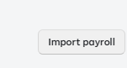 on the main page of “Salary payrolls” section (see Fig 6.) in two ways convenient for the user.
Way 1.
Implies import of the payroll in iBank2(txt) format – the import window tag “Classic format”.
Such payroll import format allows to upload one payroll only and at the same time, in order to save it, the user has to specify manually the accrual period and the accrual type in the interface.

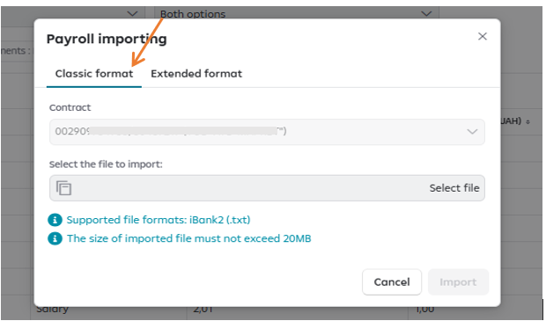
The file will be checked first for viruses, then the data in the uploaded file will be verified. As a result, the verification result will be displayed in the form.

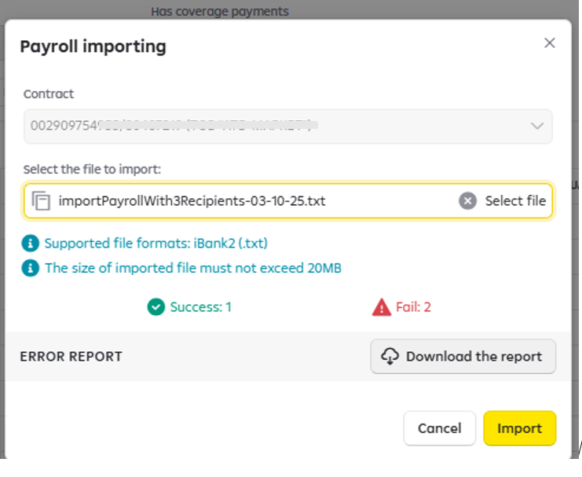

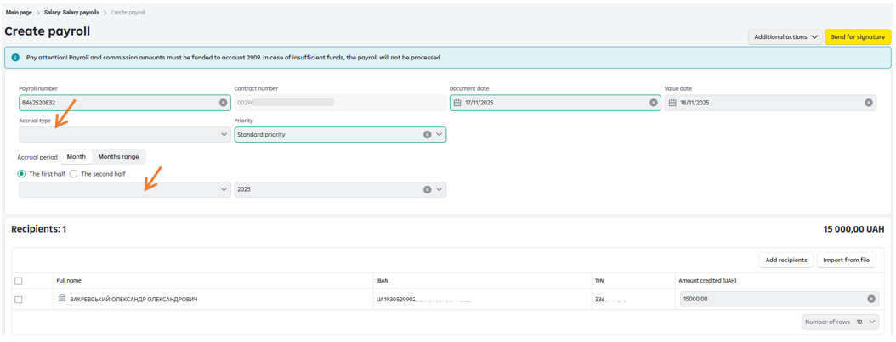

Example of the file:

Description of the fields.
Document reference | Field name | Field content
DATE_DOC | Document date. | Optional field.  If the payroll date in the file is missing, the system will assign its value automatically – the current date.  In case of specifying in the file of the date in the explicit form, it should correspond to the current date.  Importing payrolls with a past or a future date is PROHIBITED.
NUM_DOC | Document number. | Optional field.  If the payroll number is the file is missing, the system will assign it automatically. The payroll number specified by the user in the file will be transferred by the system during the import.
VALUE_DATE | Value date. | Optional field. It cannot correspond to the current date. Is used, if conducting of the payment under the payroll has to be postponed – carried out on the specified value date, but not more than by 30 days.
CARD_HOLDERS.0.CARD_NUM | Recipient’s IBAN. | Mandatory field.
CARD_HOLDERS.0.CARD_HOLDER | Recipient’s full name. | Mandatory field.
CARD_HOLDERS.0.CARD_HOLDER_INN | Recipient’s TIN. | Mandatory field.
CARD_HOLDERS.0.AMOUNT | Amount to be paid to the recipient. | Mandatory field.
* Remaining fields specified in the file will be neglected by the system during the import.
Way 2.
Implies import of a payroll in *txt format – the import window tag “Extended format”.
Such payroll import format allows to upload both one or several payrolls from one file. In this case, in order to save it, the user does not need to specify manually in the interface the accrual period and accrual type. The imported payrolls will be reflected at once in “New” status with the Standard processing priority, in other words – ready for signing.
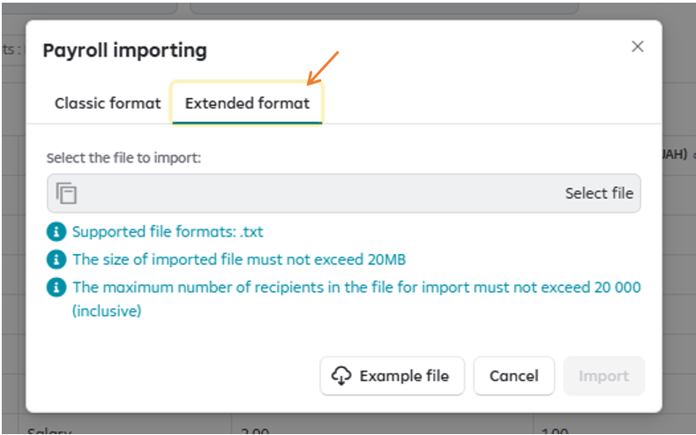
2.1. Uploading one payroll from the file.
Example of the file.

Description of the fields.
Document reference | Field name | Field content
DATE_DOC | Document date. | Optional field.  If the payroll date in the file is missing, the system will assign its value automatically – the current date.  In case of specifying in the file the date in the explicit form, it should correspond to the current date.  Importing payrolls with a past or a future date is PROHIBITED.
NUM_DOC | Document number. | Mandatory field.  Maximum number of symbols – 10.  The following symbols are allowed: the digits and upper/lower case letters: Cyrillic and Latin.
VALUE_DATE | Value date. | Optional field. It cannot correspond to the current date. Is used, if conducting of the payment under the payroll has to be postponed – carried out on the specified value date, but not more than by 30 days.
ONFLOW_TYPE | Type of payment under the payroll. | Mandatory field.  Possible values:  salItem – corresponds to the type ”Salary”;  salAdvItem - corresponds to the type “Salary, advance payments”;  advItem - corresponds to the type “Advanced payment”;  busiTripItem - corresponds to the type “Business trip”;  sickLeaveItem - corresponds to the type “Sick leave allowance”;  maternityItem - corresponds to the type “Maternity leave allowance”;  bonusesItem - corresponds to the type “Bonuses”;  othPayItem - corresponds to the type “Other payments”;  vacationItem - corresponds to the type “Vacation payments”;  landRentItem - corresponds to the type “Land plot, land shares lease payment”;  scholarshipItem - corresponds to the type “Scholarship”;  unemployAssistItem - corresponds to the type “Unemployment allowance”;  othPayItem - corresponds to the type “Other payments”;  dismissItem - corresponds to the type “Severance payment”.  Example of filling in the field for the accrual type Salary.
ONFLOW_OTH_PAY_ITEM_COMMENT | Text comment to the “Other payments” payment type. | Optional field.  Is used, if a voluntary accrual type should be specified while making payment (is carried out via “Other payments” payment type).  For example, the payment of the type “Allowance paid to compensate damage to health caused by the Chornobyl Nuclear Power Plant accident”.  The payment purpose in the payroll should be indicated as follows:  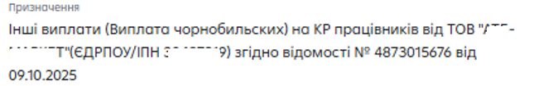  The following should be specified in the file:  The length of the field value should not exceed 45 symbols. If the field value is longer, the import will be not done and the system will produce an error.
PERIOD_START | Accrual period beginning date. | Mandatory fields*, based on which the accrual period under the payroll is automatically calculated.  1) If, while making the payment, the 1st half of the month has to be specified in the payroll payment purpose, for example:    The following should be specified in the file:  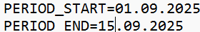  2) If, while making the payment, the 2nd half of the month has to be specified in the payroll payment purpose, for example:  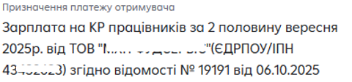  The following should be specified in the file:  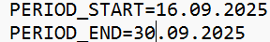  3.) If, while making the payment, only the accrual month has to be specified in the payroll payment purpose, for example:    The following should be specified in the file:  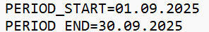  4.) If, while making the payment, several accrual months have to be specified in the payroll payment purpose, for example:  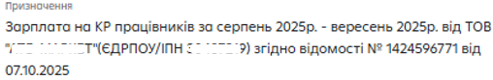  The following should be specified in the file:  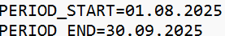  5) If for a certain payment type, the is no need to specify the accrual period at all (sick leave payment, business trip, other payments etc.), the following should be specified in the field:  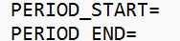
PERIOD_END | Accrual period end date.
SALARY_TRANSIT_ACCOUNT | Transit account number 2909 in IBAN format. | Mandatory field.  The transit account under the contract, under which the payment is carried out, is specified.
CARD_HOLDERS.0.CARD_NUM | Recipient’s IBAN. | Mandatory field.
CARD_HOLDERS.0.CARD_HOLDER | Recipient’s full name. | Mandatory field.
CARD_HOLDERS.0.CARD_HOLDER_INN | Recipient’s TIN. | Mandatory field.
CARD_HOLDERS.0.AMOUNT | Amount to be paid to the recipient. | Mandatory field.

2.2. Uploading several payrolls from the file.

Example of the file:

The field description is similar to that of the previous item. If several payrolls should be imported at the same time, data on each of them should be added step by step, in compliance with all the requirements in terms of filling in the fields according to clause 2.1. Each subsequent payroll is separated from the previous one by one empty line (see the example in the file).

In case of import errors while using both ways, the system will propose to the user to download the file containing the description of the import errors that reflects only the unsuccessful import cases among all payrolls reflected in txt file.
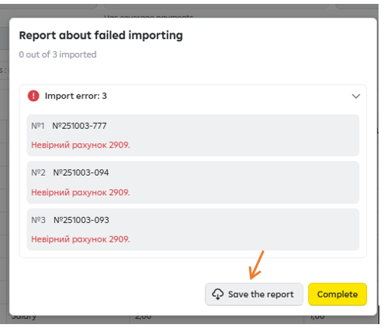
Example of the file.

Signing a payroll.

The signing function is called out in the following ways:

- In the payrolls list.
  - To perform the action, press  and in the drop-down list choose the action “Sign”. 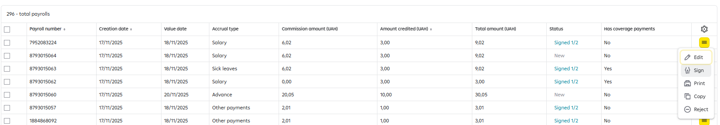

  - To perform the action, choose the required payroll (or several payrolls) via the check-box to the left and choose the action “Sign”.
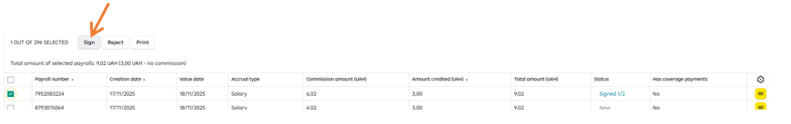
- On the payroll details page.
To perform this action, click on the button 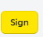 .
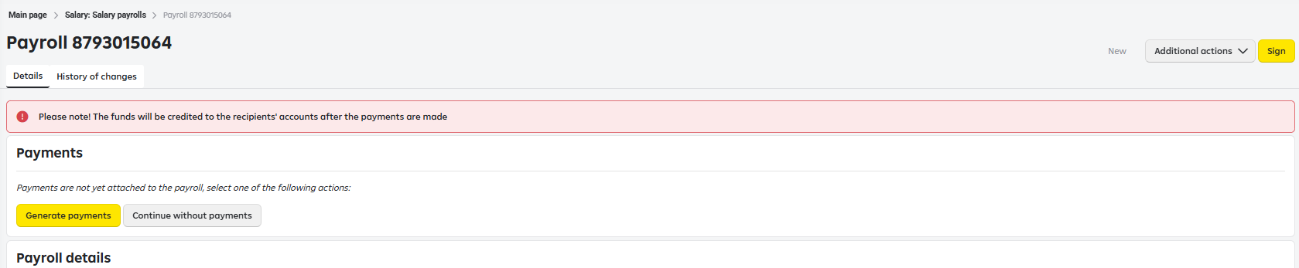

Editing a payroll

The editing function is called out in the following ways:
- In the payroll list. To perform this action, click on  and select the Edit action from the drop-down list.
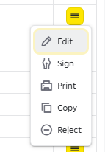

- On the payroll details page. To perform this action, click on the button  and in drop-down list select .

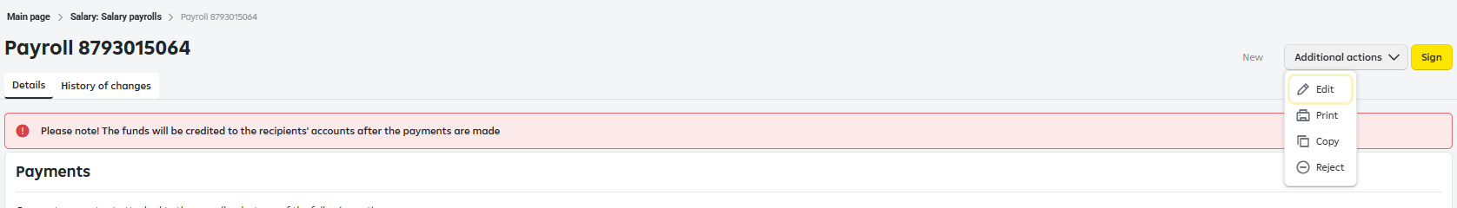

As a result, the payroll editing form will open, in which you can make the necessary changes.

  - Searching recipients on the payroll details page

Searching and selecting recipients while adding on the payroll details page (in the editing mode).

In the payroll editing mode, a window for adding the recipients to the payroll becomes available.
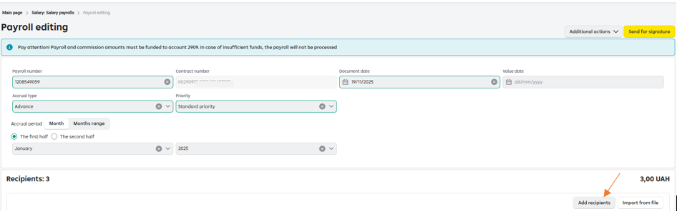

When you click, an employee search field becomes available, it can be filtered by the criterion full name, IBAN, TIN.

Example.
The window is opened on page No.1 of the recipients list:
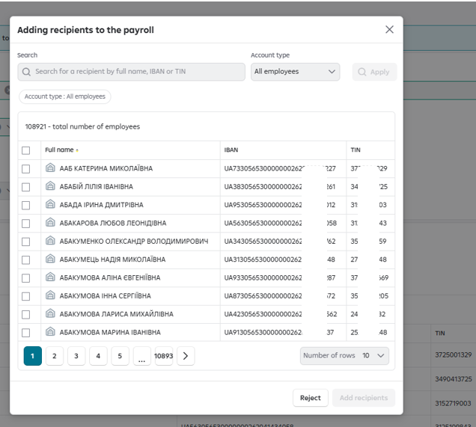
Enter in the recipient search field the full name of the recipient not present on page No.1 and press “Apply” button.

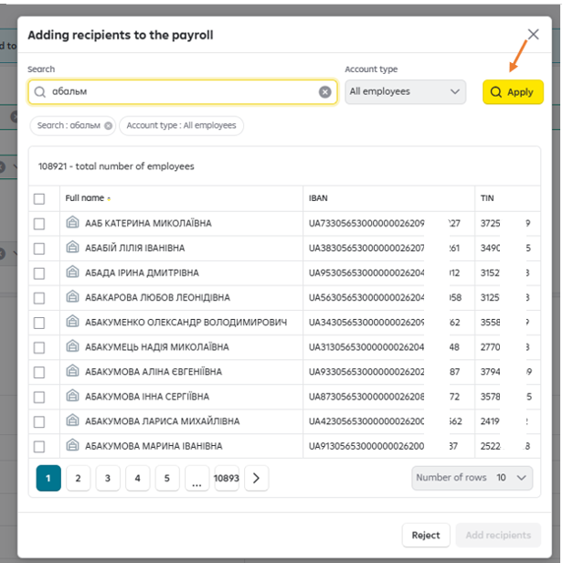

The list will be filtered by the set search criterion:

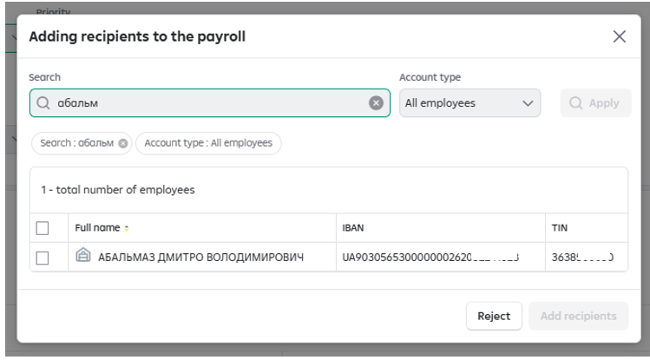

Select the required recipient (tick the respective check-box to the left of the record with the information on the employee):

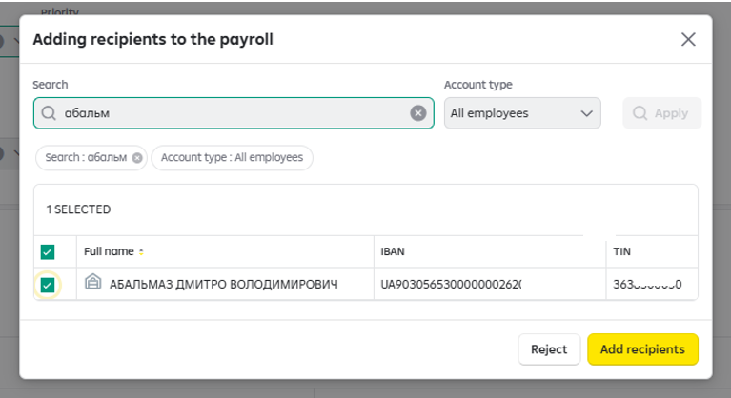
Clear the search field, press “Apply” button and the list will be opened on the first page again, where you can select two more employees to be added to the payroll:
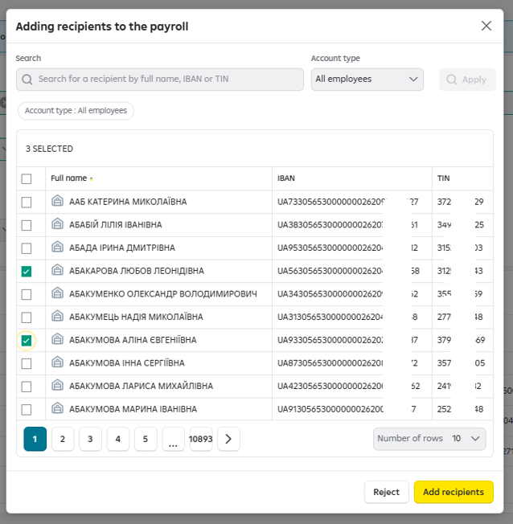
Press the button “Add recipients”. As a result, all three selected recipients will be added to the payroll.

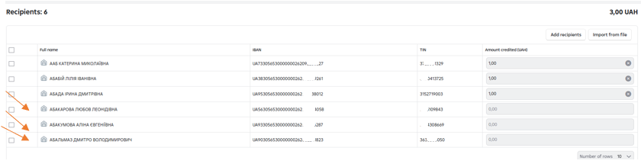

IMPORTANT: while selecting the employees in the window “Adding recipients to the payroll”, the search covers all pages, but the check-box “Select all” applies to the current dictionary page only. Thus, if you need to select all the employees on all the pages, you need to check the checkbox “Select all” on every page and only after that press the button “Add recipients”.

Example.
The window is opened on page No.1 of the recipients list:

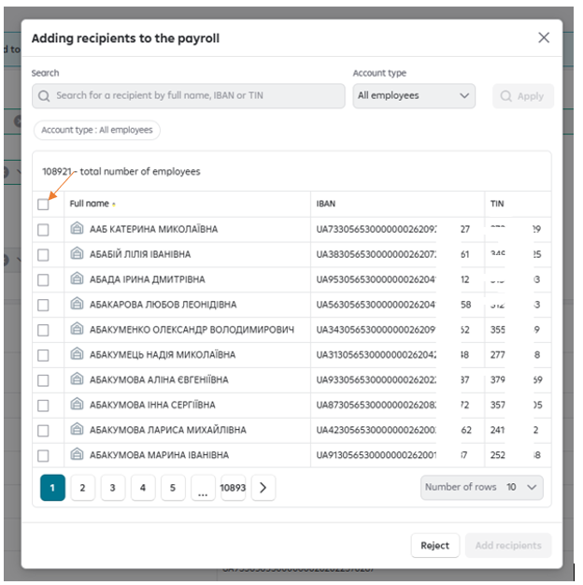

Check the checkbox “Select all”. All the employees displayed on page No.1 are selected:

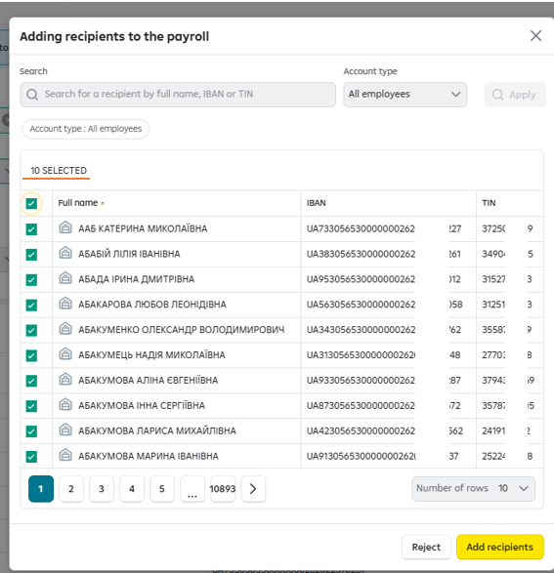

Go to page No.2, where other recipients not yet selected for adding to the payroll are displayed:

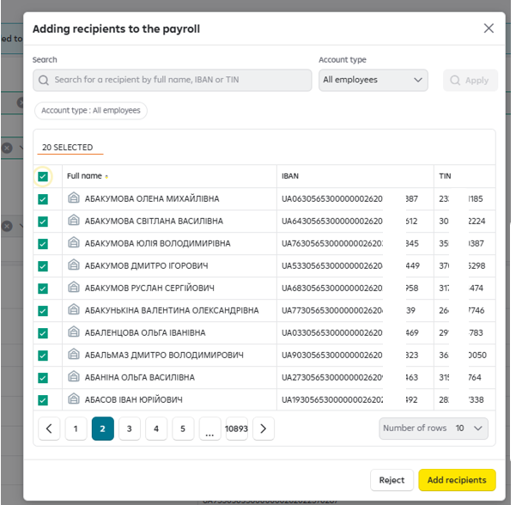

Check the checkbox “Select all”, as a result all the employees displayed on page No.2 are selected.

Press the button “Add recipients”. As a result, all the selected recipients from both pages will be added to the payroll:

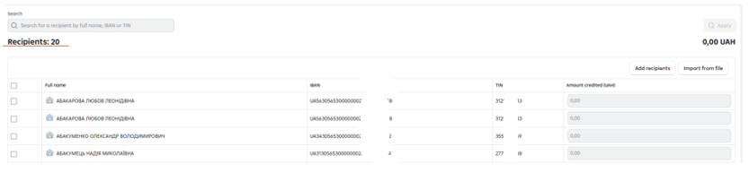

Recipients search and selection on the payroll details page (without using editing mode).

The recipients search field is not available on the payroll details page. To search an employee by his/her full name, IBAN, TIN, you need to use Internet-browser means to conduct the search on the page (it can be called out with the key shortcut Ctrl+F).
A field for entering the search criterion will appear on the page. It is sufficient to enter the search criterion (for example, Tax ID) and to press the key Enter on the keyboard. All the found options will be displayed on the page:
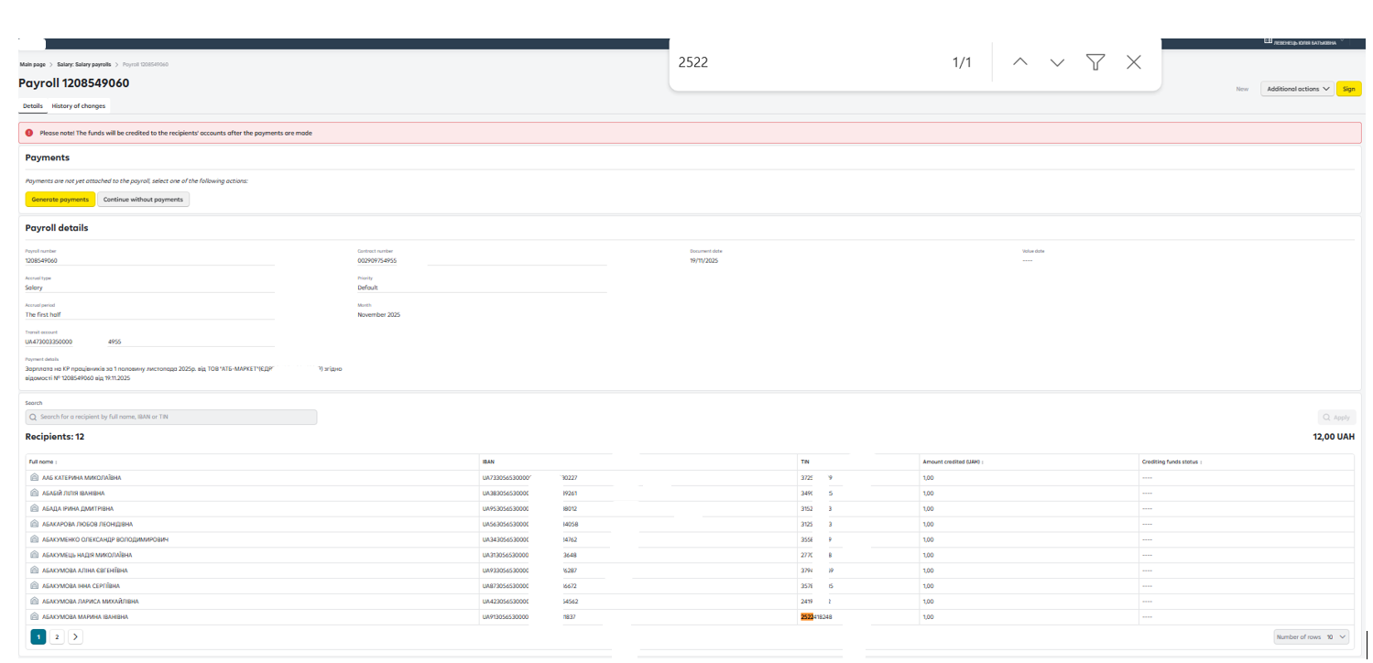
Please, note: search of the recipient via the search function in the browser applies to the recipients displayed on the current page only. To carry out search among the recipients on another page, you need to go to this page and repeat the procedure.

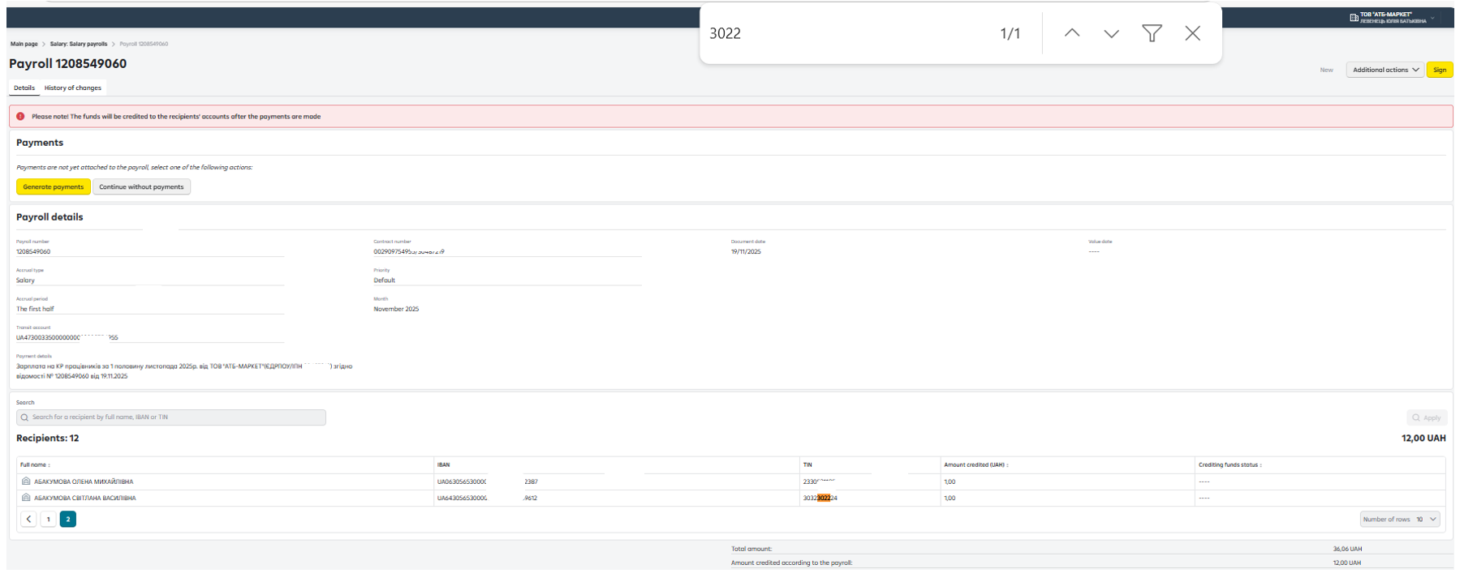

Rejecting a payroll.

The Payroll rejection function is called out in the following ways:

- In the payrolls list.
1.1. To perform the action, press and choose the action “Reject” in the drop-down list.

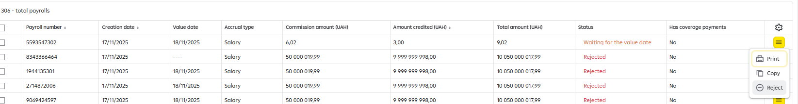

  - To perform the action, choose the required payroll (or several payrolls) via the check-box to the left and select the action “Reject”.

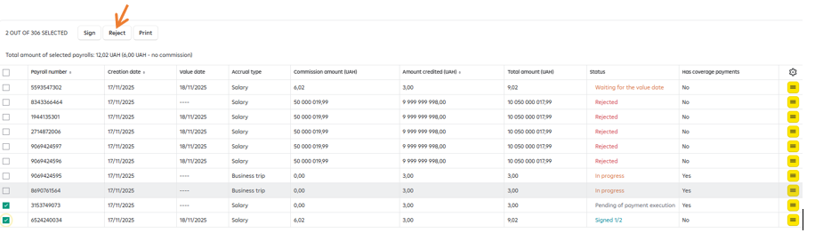

- On the payroll details page.
To perform the action, press the button 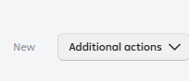 and choose the action “Reject” in the drop-down list.

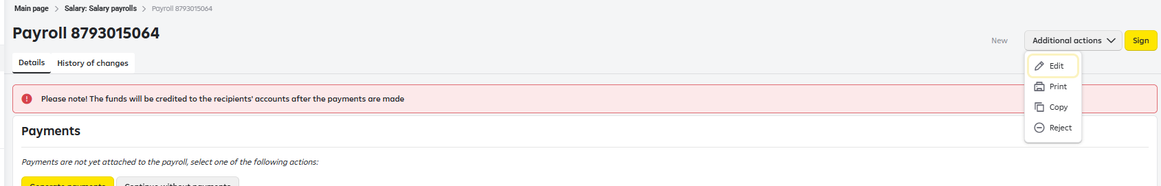

Deleting a payroll in “Drafts” tag

The function of deleting a payroll with “Draft” status is called out in two ways:

- In the payroll list.
  - To perform the action, press the button and choose the action “Delete” in the drop-down list.

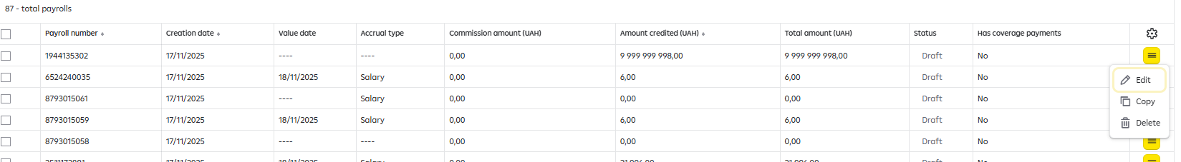

  - To perform the action, choose the required payroll (or several payrolls) via the check-box to the left and select the action “Delete”.

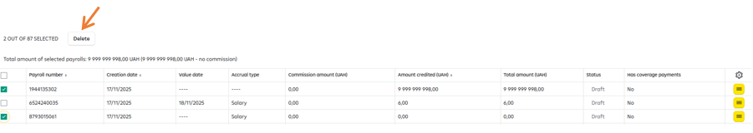

- On the payroll details page.
To perform the action, press the button  and choose the action “Delete” in the drop-down list.

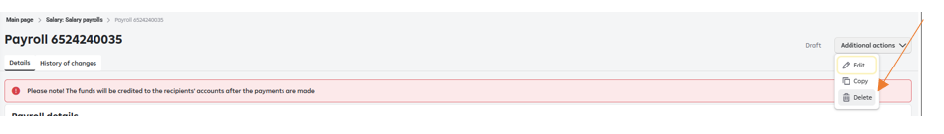

Copying a payroll.

A payroll can be copied in the following ways:

- In the payrolls list.
To perform the action, press the button and choose the action “Copy” in the drop-down list.

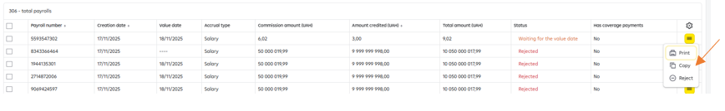

- On the payroll details page.
To perform the action, press the button  and choose the action “Copy” in the drop-down list.

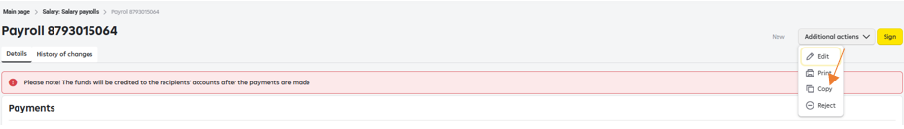

Printing a payroll.

A payroll can be printed in the following ways:

- In the payrolls list.
  - To perform the action, press the button and choose the action “Print” in the drop-down list.
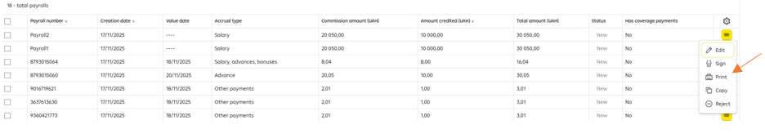

  - To perform the action, choose the required payroll (or several payrolls) via the check-box to the left and select the action “Print”.

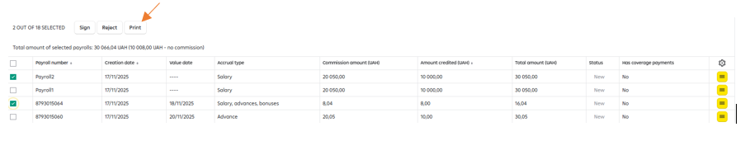

Important!

Bulk printing of the payrolls allows to print simultaneously several payrolls, in which the maximum number of the funds recipients does not exceed 10,000 persons.
In case of exceeding this number of the recipients, the system will produce an error notice:

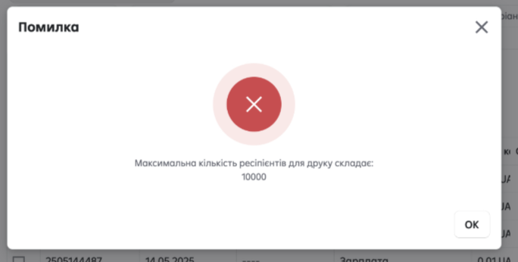

In this case, devide the payrolls into several groups for printing.
If you need to print one payroll including the number of the recipients exceeding 10,000 persons, please, do it in the way described in clauses 1.1. and 2. of the section.

Bulk printing of payrolls allows to print payrolls in Ukrainian only.
While selecting the Bank’s stamp to be reflected during printing – the Bank’s stamp will be available in the printed form of the payroll with the status “Executed” and “Partially executed”.
While selecting the visualisation of the users’ EDS – the information will be available in the payrolls that were signed by the users.

- On the payroll details page.
To perform the action, press the button 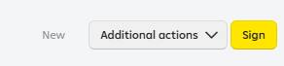 and choose the action “Print” in the drop-down list.

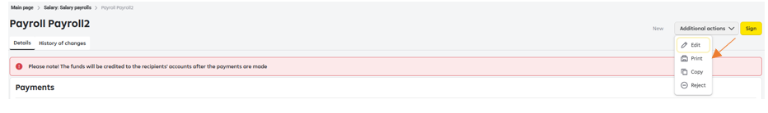

Letters sent within the framework of the Salary Project

To create and to work with the letters as regards connecting, dismissal of employees from the Salary Project, setting/cancellation of the part-time employee status, extension of the salary cards validity term, payroll rejection, return of funds transferred by mistake/funds transferred in an excessive amount within the Salary Project, go to the section “Letters” in the main menu (see Fig. 21).

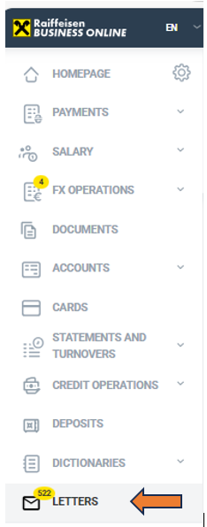

Fig. 21. Menu – “Letters”

To create letters on the subjects concerning the Salary project, press the button “Write a letter” in “Letters” section. (see Fig. 22).
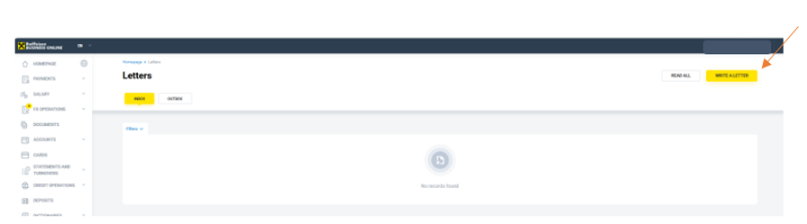
Fig. 22 “Letters” section

Choose the required subject in the form:
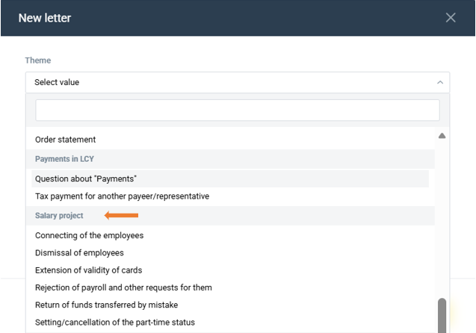

Fig.23

Having created a letter, press the button “Sign”.

  - Letter as regards rejection of payrolls and other requests for them

To create a letter as regards rejection of a payroll, press the button “Write a letter” (see Fig. 22). Choose the subject “Rejection of payroll and other requests for them” (Fig. 23) and fill in the form (Fig. 24).
Having created a letter, press the button “Sign”.

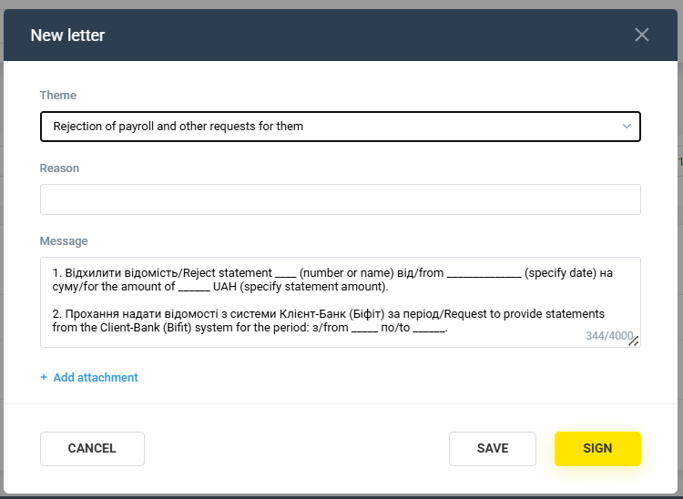

Fig.24.

  - Letter as regards setting/cancellation of the part-time employee status

To create a letter as regards setting/deactivating of the part-time employee status, press the button “Write a letter” (see Fig. 22). Choose the subject (Fig. 23) “Setting\cancellation of the part-time status” and fill in the form (Fig. 25).
Having created a letter, press the button “Sign”.

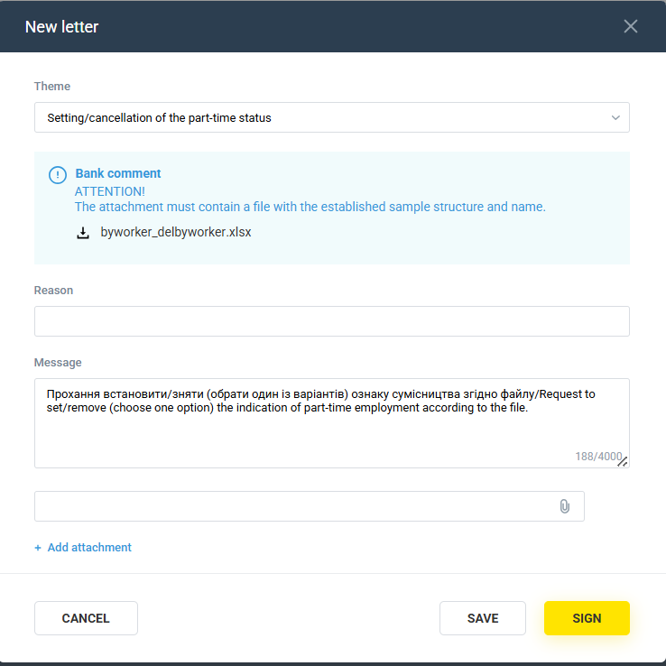

Fig.25.

Letter as regards dismissal of an employee from the Salary Project

To create a letter as regards dismissal of an employee from the Salary Project, press the “Write a letter” button. (see Fig. 22). Choose the subject (Fig. 23) “Dismissal of employees” and fill in the form (Fig. 26)
Having created a letter, press the button “Sign”.

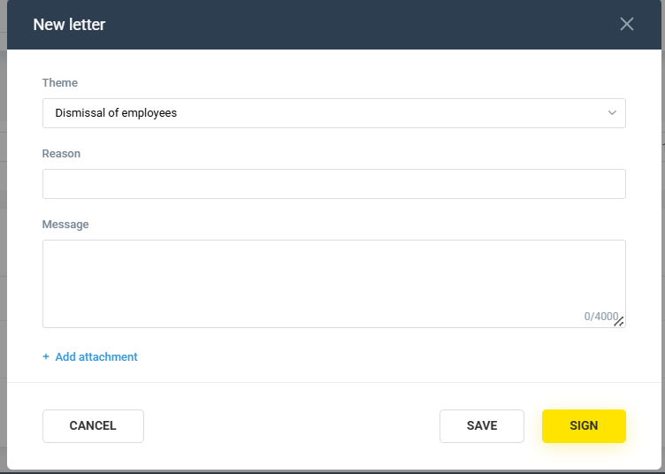
Fig.26

  - Letter as regards return of funds transferred by mistake

To create a letter as regards the return of the funds transferred by mistake, press “Write a letter” button (see. Fig. 22). Choose the subject (Fig. 23) “Return of funds transferred by mistake” and fill in the form (Fig. 27).
Having created a letter, press the button “Sign”.
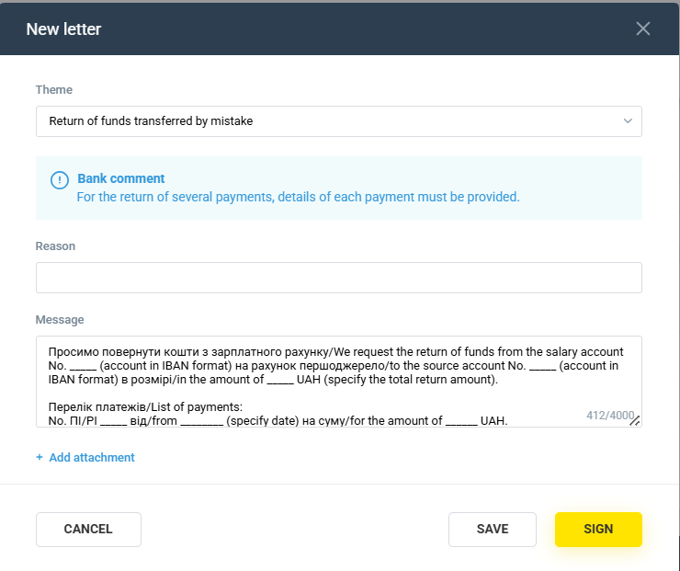

Fig. 27

  - Letter as regards connecting the employees to the Salary Project

To create a letter as regards connecting the employees to the Salary Project, press “Write a letter” button (see Fig. 22). Choose the subject (Fig. 23) “Connecting of the employees” and fill in the form (Fig. 28).
Having created a letter, press the button “Sign”.

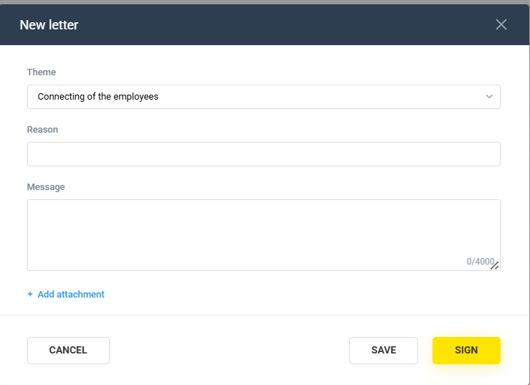

Fig. 28.

  - Letter as regards extension of the salary cards validity term

To create a letter as regards the extension of validity term of the cards, click on the “Write a letter” button (see Fig. 22). Choose the subject (Fig. 23) “Extension of validity of cards ” and fill in the form (Fig. 29).
Having created a letter, press the button “Sign”.

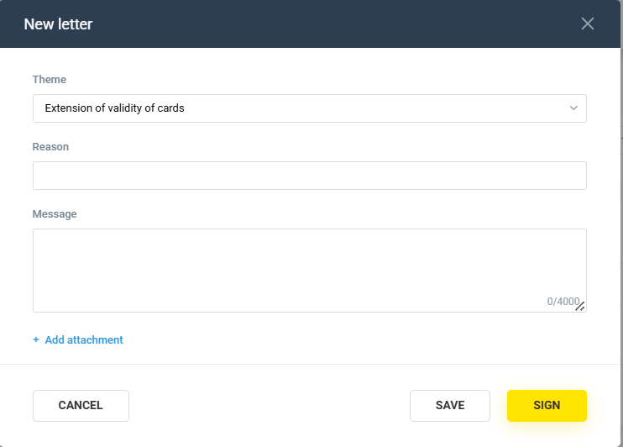
Fig.29

Enjoy your work!
Raif makes it more convenient!

0 800 505 770 (in Ukraine) | +38 (044) 495 41 40 (for calls in Kyiv and from abroad)
clientbank.support@raiffeisen.ua

